SMART SYSTEM FOR OPTIMIZED ORGANIC CROP
ROTATION USING PRECISION AGRICULTURE DATA

Ranasinghe R.A.D.M

(IT20244552)

Bachelor of Science Special (Hons) in Information Technology Specialization in Software Engineering

Department of Computer Science and Software Engineering

Sri Lanka Institute of Information Technology
Sri Lanka

September 2023

SMART SYSTEM FOR OPTIMIZED ORGANIC CROP
ROTATION USING PRECISION AGRICULTURE DATA

Ranasinghe R.A.D.M

(IT20244552)

Dissertation submitted in partial fulfillment of the requirements for the Bachelor of Science (Hons), Information Technology, Specialization in Software Engineering

Department of Computer Science and Software Engineering

Sri Lanka Institute of Information Technology
Sri Lanka

September 2023

DECLARATION
I declare that this is my own work when considering my individual components of the research,and this dissertation does not incorporate without acknowledgment any material previously submitted for a degree or diploma in any other university or institute of higher learning and to the best of our knowledge and belief it does not contain any material previously published or written by another person except where the acknowledgment is made in the text.

Name | Student ID | Signature
Ranasinghe R.A.D.M. | IT20244552 | 

The above candidates are carrying out research for the undergraduate Dissertation under my supervision.

Signature of the supervisor Date

ABSTRACT
This research aims to address the challenge of crop rotation planning for organic farmers by developing a rule-based knowledge base system that considers various factors affecting crop growth and health, such as soil health, weather and climate data, and pests and diseases. By providing a tailored crop rotation plan for each farm or land, the system aims to improve the productivity and sustainability of organic farming practices, thereby contributing to the overall development of the agricultural industry. To develop this system, the research team will use IoT devices to gather realtime data on soil health and climate conditions and integrate this data with farmers' inputs to generate a crop rotation plan that optimizes yield and sustainability. The knowledge base will be developed based on the expertise of agricultural professionals, with a user-friendly interface for updates and maintenance. By continuously updating the knowledge base with new information and expertise, the system will maintain its accuracy and effectiveness over time. This research project involves a team of four members, with each member assigned specific tasks to accomplish. One member will
be responsible for gathering knowledge from agricultural experts and creating a userfriendly interface for knowledge base updates. The other three members will be responsible for data retrieval on soil health, climate, and pests and diseases. Through
collaboration and coordination, the team aims to develop a comprehensive and effective crop rotation management system that will benefit the organic farming community and contribute to sustainable agriculture.
Keywords – Crop Rotation, knowledge base, Crop recommendation, Rule
based Expert System, Organic farming, Drools Rule Base

ACKNOWLEDGEMENT
I would like to express my sincere gratitude and appreciation to my supervisor, Mr Udara Samaratunga, and co-supervisor, Dr. Nuwan Kodagoda, for their invaluable guidance, encouragement, support, and dedication throughout my one-year research journey. Their advice and assistance have been continuous support in guiding the direction of our research project(RP) and making it a success without any undue pressure. I am truly grateful for their constant availability and willingness to help whenever needed and it was a great privilege to work with them during this research. I also extend my heartfelt thanks to Dr. Jayantha Amararachchi, the Lecture in Charge of the Research Module, for his insightful lectures and constant guidance throughout one year that has helped me to understand the research module more thoroughly. My parents deserve a special mention for their unending support and care throughout my academic journey. Their limitless support has been a source of inspiration and motivation for me to reach my academic goals. I would also like to thank my three group members for their continuous commitment, team spirit, and hard work throughout this research journey that has made this research project a success. It has been an honor to work with such a dedicated team, and I am grateful for their support and encouragement. Finally, I would like to express my sincere gratitude to the research panel, TAF Panel, and CDAP staff for their valuable advice, instructions, and time and for accepting our research topic by giving us the chance to do this research.

TABLE OF CONTENTS

DECLARATION II
ABSTRACT II
ACKNOWLEDGEMENT III
TABLE OF CONTENTS IV
LIST OF FIGURES VI
LIST OF TABLES VII
LIST OF APPENDICES VIII
LIST OF ACRONYMS AND ABBREVIATIONS IX
1 INTRODUCTION 1
1.1 Background & Literature Survey 2
1.2 Research Gap 9
2 RESEARCH PROBLEM 12
3 OBJECTIVES 13
2.1 Main Objective 13
2.2 Specific Objectives 14
4 METHODOLOGY 15
4.1 Problem Statement 15
4.2 Requirement Gathering and Analysis 15
4.3 System Design and Implementation 17
4.3.1 Overall System Diagram 17
4.3.2 Individual System Diagram 19
4.4 Data Collection 21
4.5 Implementation 22
4.5.1 Creating the Expense Classification Model 22
4.6 Application Implementation 29
4.7 Deployment and Maintenance 29
4.8 Tools and Technologies 29
4.9 Commercialization 30
5 TESTING & IMPLEMENTATION 31
5.1 Test Plan and Strategy 31
5.2 Test Case Design 33
6 RESULTS & DISCUSSION 38
6.1 Results 38
6.2 Research Findings 45
6.3 Discussion 48
7 CONCLUSION 49
REFERENCES 50
APPENDIX A: SURVEY 52
APPENDIX B: WORK BREAKDOWN CHART 59
APPENDIX C: GANTT CHART 60
APPENDIX D: PLAGIARISM REPORT 61

LIST OF FIGURES

Figure X.X: XXXXXXXXXXXXXXXXXXXXXXXXX X7

LIST OF TABLES

Table 8: XXXXXXXXXXXXXXXXXXXX. X8

LIST OF APPENDICES
Appendix A. 1: Survey Description 52
Appendix A. 2: Survey Questions from 2 to 4 53
Appendix A. 3: Survey Questions from 5 to 8 54
Appendix A. 4: Survey Question 9 55
Appendix A. 5: Survey Question 10 55
Appendix A. 6: Survey Questions 11 and 12 55
Appendix A. 7: Survey Question 13 56
Appendix A. 8: Survey Question 14 56
Appendix A. 9: Survey Questions 15 and 16 57
Appendix A. 10: Survey Questions 17 and 18 57
Appendix A. 11: Survey Questions 19 to 21 58
Appendix A. 12: End of Survey Questions 58
Appendix B. 1: Work Breakdown Chart 59
Appendix C. 1: Gantt Chart 60
Appendix D. 1: Turnitin Report 61

LIST OF ACRONYMS AND ABBREVIATIONS
Table 1: List of Acronyms and Abbreviations
Abbreviations  RP  SLIIT  CRM  UI  IOT  DB  KIE  DMN  UX | Description  Research Project  Sri Lanka Institute Of Information Technology  Crop Rotation Management  User Interface  Internet Of Things  Database  Knowledge Inspired Server  Decision Model Notation  User Experience

INTRODUCTION

Background & Literature Survey
As a sustainable alternative to conventional agriculture, organic farming has attracted growing interest in recent years. To maintain soil health and fertility, increase biodiversity, and reduce the use of synthetic pesticides and fertilizers, it involves the use of natural fertilizers, biological pest management, and crop rotation [1]. By alternating various crops on the same plot of land over time, crop rotation is a crucial part of organic farming because it helps to control pests and diseases, enhance soil structure, and retain soil nutrients [2].
But for farmers, coming up with a thorough and effective crop rotation strategy can be a difficult process. Several aspects are taken into account during the process, including soil health, past pest and disease activity, crop nutrient needs, climate and weather patterns, market demand, and financial viability [3]. Crop rotation planning traditionally relied on experience and intuition, which may not necessarily produce the most useful plans.
There is a rising demand for software solutions that can help farmers create and optimize crop rotation plans to solve this issue. These solutions make use of data from precision agriculture, machine learning, and software engineering concepts to give farmers tools that are simple to use, scalable, and accessible [4].
The future of organic farming depends on the creation of such a tool. Many issues, such as climate change, degraded soil, and dwindling biodiversity, face the agricultural sector [5]. Innovative solutions that can increase agriculture's sustainability and profitability while minimizing its detrimental effects on the environment and human health are required to address these concerns. By maximizing crop yields, improving soil health, and reducing the use of synthetic inputs, a crop rotation planning tool for organic farming can aid in the achievement of these objectives. The UN Sustainable Development Goal 2 is to "eliminate hunger, ensure food security and enhanced nutrition, and promote sustainable agriculture," and these solutions are in accordance with that objective [6].
Crop rotation planning tools have gained in popularity in recent years as farmers seek to increase crop yields while improving the sustainability and health of their land. Many tools with unique combinations of features and technology have been developed to aid farmers in developing efficient and effective crop rotation plans.
In recent years, the research and development of crop rotation planning tools has grown in popularity as farmers look to maximize crop yields and enhance the sustainability and health of their soil. To help farmers create efficient and optimal crop rotation plans, several tools have been developed, each with an own combination of features and technologies.
CropRotationPlanner is one such instrument, created by academics at the University of Wisconsin-Madison (Chang et al., 2014). With the help of this tool, farmers may enter details about their fields, such as crop history, soil types, and nutrient levels, using an interactive web-based interface. Based on this data, the program creates a personalized crop rotation plan that takes economic profitability, pest and disease management, and soil health into account. In comparison to conventional crop rotation planning techniques, the tool has been found to dramatically boost crop yields and reduce fertilizer runoff. It uses linear programming algorithms to optimize the plan.
The University of Guelph team also created the Crop Sequence Calculator (Schoenauet al., 2013). This application creates crop rotation plans that maximize soil health and crop yields using a database of crop yields, nutrient needs, and pest and disease susceptibility. Farmers can use the tool to create personalized plans by entering details about their own land and crop management techniques. The device has been demonstrated to increase agricultural yields and economic viability while enhancing soil health and reducing weed and insect burden.
Another popular tool for crop rotation planning is the Decision Support System for Agrotechnology Transfer (DSSAT) (Jones et al., 2003). Many models for modeling crop development, nitrogen uptake, and pest and disease pressure are part of the software suite known as DSSAT. Farmers can use the program to simulate various crop rotation scenarios and assess how they will affect the health of the soil, crop yields, and financial success. As compared to conventional crop rotation planning techniques, the tool has been employed in multiple studies and has been demonstrated to increase soil fertility and crop yields.
The Agricultural Production Systems Simulator (APSIM), the CropSyst model, and the Integrated Farm System Model (IFSM) are other crop rotation planning tools that have been developed (Gassman et al., 2010; Stockle et al., 2003; Rotz et al., 2010). To simulate crop growth, nutrient uptake, pest and disease pressure, and to provide optimized crop rotation schedules, each of these tools makes use of a different collection of technologies and algorithms.
In conclusion, as farmers work to maximize crop yields and enhance the sustainability and health of their land, crop rotation planning tools have grown in importance in recent years. Using a range of technologies and algorithms to model crop growth, nutrient uptake, and pest and disease pressure, a number of tools have been created to help farmers create efficient and optimized crop rotation plans. These methods have been demonstrated to considerably boost crop yields, decrease insect and disease pressure, and improve soil health.

Research Gap
Based on the literature review, it is evident that there is a research gap in the domain of developing a smart system for optimized organic crop rotation, integrating precision agriculture data. While some efforts have been made to create software for crop rotation planning, they do not fully utilize the potential of precision agriculture data to optimize the crop rotation plans.
Most of the existing crop rotation planning tools rely on conventional methods that may overlook various factors affecting crop yields and soil health, such as historical data on pests and diseases, weather patterns, and nutrient requirements. Although a few systems incorporate data on soil health and fertility, there is a lack of consideration for precision agriculture data, including aspects like soil moisture, plant health, and yield variability.
Considering the continual advancement in precision agriculture technologies, there is a pressing need to incorporate these data sources into crop rotation planning tools to improve crop yields, minimize input costs, and promote sustainability. Developing a smart system for optimized organic crop rotation, leveraging precision agriculture data, can provide farmers with more efficient and effective crop rotation plans tailored to the specific needs of their crops and soils.
Consequently, the research gap in existing crop rotation systems is the absence of consideration for precision agriculture data in the crop rotation plan creation process.
Furthermore, there is currently no crop rotation management (CRM) system catering to the specific context of organic crop rotation in Sri Lanka. Moreover, no studies or available systems have been found that utilize real-time precision agriculture data through the Internet of Things (IOT) for creating organic crop rotation plans. Similarly, no studies or systems have been identified that take into account the current pest and disease conditions on the farm when formulating a crop rotation plan.

CRM Tool  Feature | [1]ROTOR 4.1 | [2]FruchtFolge | [3]FARMs | [4]MORDMAgro | Proposed System
Build for organic farming |  | 
Can apply output crop rotation plan for Sri Lanka
Use real time precision agriculture data
Consider previous grown crops pest and disease history

RESEARCH PROBLEM
Despite the growing significance of organic farming and the critical role of crop rotation in ensuring sustainable agriculture, the absence of accessible and efficient crop rotation planning tools continues to pose a considerable challenge for farmers [1]. Conventional approaches to crop rotation planning primarily rely on experiential knowledge and intuition, often neglecting crucial determinants such as soil health, historical pest and disease records, crop nutrient demands, climatic conditions, and the dynamic landscape of market demands and profitability [2]. Consequently, these methods might not yield the best results for farmers striving for sustainable and profitable organic farming practices.
While certain tools for crop rotation planning do exist, they remain limited in their integration of precision agriculture data, failing to fully harness the potential benefits of these technological advancements [3]. This limitation underscores the necessity for a more sophisticated approach, one that amalgamates precision agriculture data to generate comprehensive and optimized organic crop rotation plans. By considering an exhaustive array of pertinent factors, such as those mentioned earlier, this smart system could equip farmers with accessible, user-friendly planning tools tailored to their specific farming requirements [4].
Hence, there arises a pressing need for the development of a comprehensive and integrated smart system for optimized organic crop rotation, leveraging precision agriculture data. Such a system, when effectively designed and implemented, has the potential to revolutionize the landscape of organic farming, enhancing its sustainability, profitability, and long-term viability. By addressing the current limitations and gaps in crop rotation planning, this integrated approach could lead to more informed decision-making and improved agricultural practices, benefitting farmers, consumers, and the environment alike.

OBJECTIVES
The main aim of the proposed research is to create and assess a smart system designed for optimizing organic crop rotation by leveraging precision agriculture data. The primary objective is to fill the gap that currently exists in crop rotation systems, where the incorporation of precision agriculture data is not taken into account during the formulation of crop rotation plans.
The ultimate ambition of this research is to contribute significantly to the progress of sustainable agricultural practices, particularly within the sphere of organic farming. Through the development of this smart system for optimized organic crop rotation, the intention is to provide farmers with a practical tool that can not only elevate the sustainability and profitability of their agricultural endeavors but also diminish the adverse impacts on the environment and human well-being.
By facilitating the integration of precise agricultural data, the proposed system aspires to assist farmers in making informed decisions that can lead to improved resource management, enhanced crop yield, and a reduction in the reliance on potentially harmful chemical inputs. Furthermore, by promoting a more holistic approach to crop rotation planning, the research endeavors to contribute to the preservation of soil health and fertility, the mitigation of pest and disease pressures, and the conservation of natural resources.
Overall, the intended smart system aims to empower farmers with a valuable resource that can aid in achieving long-term sustainability goals, thereby fostering a more environmentally friendly and economically viable agricultural landscape.

3.1 Main Objective
The main objective of the proposed research is to develop a smart system for optimized organic crop rotation using precision agriculture data, aiming to address the existing gap in current crop rotation systems, which lack consideration for precision agriculture data during the creation of crop rotation plans.

Specific Objectives

Extract the knowledge of experts in organic crop rotation.

Write the knowledge base respected to considered parameters.

Create the crop rotation plan according to the given output from the knowledge base system.

Integrate the crop rotation plan component with other components.

METHODOLOGY

Problem Statement

Requirement Gathering and Analysis

System Design and Implementation

Overall System Diagram

Individual System Diagram

Data Collection

Implementation

Creating the Expense Classification Model

Deployment and Maintenance

Tools and Technologies

Commercialization

TESTING & IMPLEMENTATION

Test Plan and Strategy

Test Case Design

Table 3: XXXXXXXXXXXXXXXX
Test Case ID | 01
Test Case | XXXXXXXXXXXXXXXX
Test Scenario | XXXXXXXXXXXXXXXXXXXXX
Input | XXXXXXXXXXXXXXXXXXXX
Expected Output | XXXXXXXXXXXXXXXXXX
Actual Result | XXXXXXXXXXXXXXX
Status(Pass/Fail) | XXXXXXXXXXXXXXXXXXX

RESULTS & DISCUSSION

Results

Research Findings

Discussion

CONCLUSION
XX.

REFERENCES

APPENDIX A: SURVEY

Appendix A. 1: Survey Description

Appendix A. 2: Survey Questions from 2 to 4

Appendix A. 3: Survey Questions from 5 to 8

Appendix A. 4: Survey Question 9

Appendix A. 5: Survey Question 10

Appendix A. 6: Survey Questions 11 and 12

Appendix A. 7: Survey Question 13

Appendix A. 8: Survey Question 14

Appendix A. 9: Survey Questions 15 and 16

Appendix A. 10: Survey Questions 17 and 18

Appendix A. 11: Survey Questions 19 to 21

Appendix A. 12: End of Survey Questions

APPENDIX B: WORK BREAKDOWN CHART
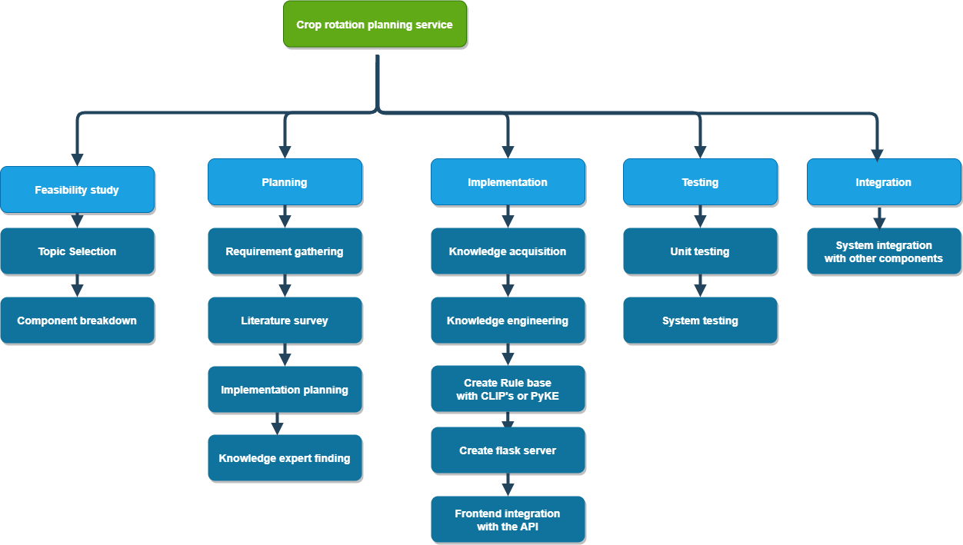
Appendix B. 1: Work Breakdown Chart

APPENDIX C: GANTT CHART
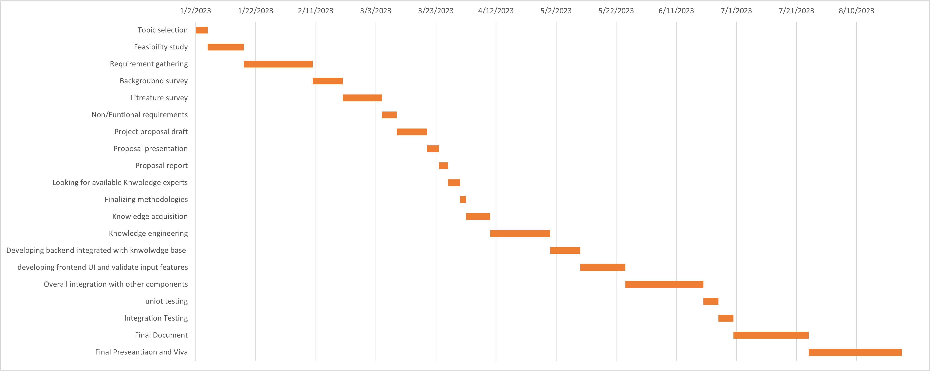
Appendix C. 1: Gantt Chart

APPENDIX D: PLAGIARISM REPORT

Appendix D. 1: Turnitin Report

