SMART SYSTEM FOR OPTIMIZED ORGANIC CROP
ROTATION USING PRECISION AGRICULTURE DATA

Samarakoon S.M.A.D

(IT20233808)

Bachelor of Science Special (Hons) in Information Technology Specialization in Software Engineering

Department of Computer Science and Software Engineering

Sri Lanka Institute of Information Technology
Sri Lanka

September 2023

SMART SYSTEM FOR OPTIMIZED ORGANIC CROP
ROTATION USING PRECISION AGRICULTURE DATA

Samarakoon S.M.A.D

(IT20233808)

Dissertation submitted in partial fulfillment of the requirements for the Bachelor of Science (Hons), Information Technology, Specialization in Software Engineering

Department of Computer Science and Software Engineering

Sri Lanka Institute of Information Technology
Sri Lanka

September 2023

DECLARATION
I declare that this is my own work when considering my individual components of the research,and this dissertation does not incorporate without acknowledgment any material previously submitted for a degree or diploma in any other university or institute of higher learning and to the best of our knowledge and belief it does not contain any material previously published or written by another person except where the acknowledgment is made in the text.

Name | Student ID | Signature
Samarakoon S.M.A.D. | IT20233808 | 

The above candidates are carrying out research for the undergraduate Dissertation under my supervision.

Signature of the supervisor Date

ABSTRACT
The proposed approach is an Internet of Things-based solution that attempts to help farmers increase crop productivity while using less fertilizer by predicting the most optimal crop for a specific soil sample. A multi objective optimization technique is used by the system to determine the best crop for a given soil sample after collecting data from soil sensors using a range of hardware and software components. The gathered data is then used with a machine learning model to improve its crop recommendation algorithms through historical data analysis and trend identification, leading to best crop growth and yields with little fertilizer use. This IoT-based solution offers farmers a more efficient and effective method of managing their crops, as they can make informed decisions on fertilizer selection based on real-time data. By leveraging the power of IoT technology and algorithmic based processing, this system can potentially help farmers to increase their crop yields with low fertilizers and contribute to the growth of the agricultural sector..

Keywords – NPK, IOT, Soil Sensors, Algorithms, Optimization Algorithm, Fertilizer, Crop Growth

ACKNOWLEDGEMENT
I would like to express my sincere gratitude and appreciation to my supervisor, Mr Udara Samaratunga, and co-supervisor, Dr. Nuwan Kodagoda, for their invaluable guidance, encouragement, support, and dedication throughout my one-year research journey. Their advice and assistance have been continuous support in guiding the direction of our research project(RP) and making it a success without any undue pressure. I am truly grateful for their constant availability and willingness to help whenever needed and it was a great privilege to work with them during this research. I also extend my heartfelt thanks to Dr. Jayantha Amararachchi, the Lecture in Charge of the Research Module, for his insightful lectures and constant guidance throughout one year that has helped me to understand the research module more thoroughly. My parents deserve a special mention for their unending support and care throughout my academic journey. Their limitless support has been a source of inspiration and motivation for me to reach my academic goals. I would also like to thank my three group members for their continuous commitment, team spirit, and hard work throughout this research journey that has made this research project a success. It has been an honor to work with such a dedicated team, and I am grateful for their support and encouragement. Finally, I would like to express my sincere gratitude to the research panel, TAF Panel, and CDAP staff for their valuable advice, instructions, and time and for accepting our research topic by giving us the chance to do this research.

TABLE OF CONTENTS

DECLARATION II
ABSTRACT II
ACKNOWLEDGEMENT III
TABLE OF CONTENTS IV
LIST OF FIGURES VI
LIST OF TABLES VII
LIST OF APPENDICES VIII
LIST OF ACRONYMS AND ABBREVIATIONS IX
1 INTRODUCTION 1
1.1 Background & Literature Survey 2
1.2 Research Gap 9
2 RESEARCH PROBLEM 12
3 OBJECTIVES 13
2.1 Main Objective 13
2.2 Specific Objectives 14
4 METHODOLOGY 15
4.1 Problem Statement 15
4.2 Requirement Gathering and Analysis 15
4.3 System Design and Implementation 17
4.3.1 Overall System Diagram 17
4.3.2 Individual System Diagram 19
4.4 Data Collection 21
4.5 Implementation 22
4.5.1 Creating the Expense Classification Model 22
4.6 Application Implementation 29
4.7 Deployment and Maintenance 29
4.8 Tools and Technologies 29
4.9 Commercialization 30
5 TESTING & IMPLEMENTATION 31
5.1 Test Plan and Strategy 31
5.2 Test Case Design 33
6 RESULTS & DISCUSSION 38
6.1 Results 38
6.2 Research Findings 45
6.3 Discussion 48
7 CONCLUSION 49
REFERENCES 50
APPENDIX A: SURVEY 52
APPENDIX B: WORK BREAKDOWN CHART 59
APPENDIX C: GANTT CHART 60
APPENDIX D: PLAGIARISM REPORT 61

LIST OF FIGURES

Figure X.X: XXXXXXXXXXXXXXXXXXXXXXXXX X7

LIST OF TABLES

Table 8: XXXXXXXXXXXXXXXXXXXX. X8

LIST OF APPENDICES
Appendix A. 1: Survey Description 52
Appendix A. 2: Survey Questions from 2 to 4 53
Appendix A. 3: Survey Questions from 5 to 8 54
Appendix A. 4: Survey Question 9 55
Appendix A. 5: Survey Question 10 55
Appendix A. 6: Survey Questions 11 and 12 55
Appendix A. 7: Survey Question 13 56
Appendix A. 8: Survey Question 14 56
Appendix A. 9: Survey Questions 15 and 16 57
Appendix A. 10: Survey Questions 17 and 18 57
Appendix A. 11: Survey Questions 19 to 21 58
Appendix A. 12: End of Survey Questions 58
Appendix B. 1: Work Breakdown Chart 59
Appendix C. 1: Gantt Chart 60
Appendix D. 1: Turnitin Report 61

LIST OF ACRONYMS AND ABBREVIATIONS
Table 1: List of Acronyms and Abbreviations
Abbreviations  RP  SLIIT  CRM  UI  IOT  DB  CSI  UX | Description  Research Project  Sri Lanka Institute Of Information Technology  Crop Rotation Management  User Interface  Internet Of Things  Database  Crop Sutaibility index  User Experience

1 INTRODUCTION
Farming has been a fundamental part of our lives for generations, providing us with food and livelihoods. However, the world of farming is changing, thanks to new technologies. This thesis explores how we can use smart devices that connect to the internet to help farmers make better choices about what to plant and how to manage their soil. In farming, two things are crucial: knowing the quality of the soil and choosing the right crops. Soil quality depends on factors like Nitrogen (N), Phosphorus (P), and Potassium (K), often referred to as NPK. Traditional farming methods often rely on guesswork when it comes to planting crops. This can lead to poor crop yields, resource wastage, and harm to the environment. To tackle this, we use special gadgets that can tell us about the NPK values in the soil. These values help us decide which crops will thrive in that specific soil.
The primary aim of this thesis is to create a system that uses technology to suggest which crops are best suited for a particular soil based on NPK values from these gadgets. Our goal is to assist farmers in making informed decisions, growing better crops, and using fewer resources. We tested three different methods (Random Forest, Decision Tree, and Support Vector Classifier) to determine the most effective method for crop recommendations. Our findings show that the Random Forest method works the best, so that's what we use in our system.
We also recognize that farmers might want to grow different crops than the ones we suggest. To help with this, we've gathered advice from farming experts. This advice guides you on how to adjust your soil's NPK values if you want to plant something else. Our system combines technological help and traditional farming wisdom to support farmers.To make this system user-friendly, we've created a mobile app using React Native, making it easy to access and use. Behind the scenes, there's a computer system that handles the heavy lifting. Additionally, we've created a way for farming experts to share their knowledge and keep it up-to-date.
In a nutshell, this research is about bridging the gap between traditional farming and modern technology to help farmers make informed decisions about what to grow and how to manage their soil. The result is a system that empowers farmers to make better choices, grow healthier crops, and benefit the environment and society as a whole.

Background & Literature Survey
Agriculture is the bedrock of human civilization, providing sustenance, livelihoods, and economic stability. As the world's population continues to burgeon, the need to produce more food becomes increasingly pressing. The confluence of modern technology with agriculture has given rise to a new era, one in which precision farming methods, fueled by data-driven decision-making and the integration of Internet of Things (IoT) devices, is paramount in optimizing crop production and resource conservation.Precision agriculture, sometimes referred to as smart or digital farming, is an innovative approach that seeks to judiciously apply inputs like water, fertilizers, and pesticides exactly where and when they are required. This minimizes waste, maximizes crop yield, and mitigates the environmental impact. A key aspect of precision agriculture is the understanding and monitoring of soil conditions, including factors such as soil composition, moisture levels, and nutrient content. Among these factors, the levels of Nitrogen (N), Phosphorus (P), and Potassium (K), collectively known as NPK, significantly influence plant growth and crop productivity.The role of the Internet of Things (IoT) in agriculture has been transformative, offering novel avenues for advancing farming practices. IoT involves the interconnection of everyday objects and devices to the internet, enabling them to gather, share, and analyze data. In agriculture, IoT devices have become vital tools for monitoring and collecting data from the farm environment. This data encompasses soil conditions, weather information, crop health, and equipment performance.
The Internet of Things (IoT) has transformed agriculture, offering new avenues for advancing farming practices. IoT involves connecting everyday objects and devices to the internet, enabling them to gather, share, and analyze data. In agriculture, IoT devices have become vital tools for monitoring and collecting data from the farm environment, including soil conditions, weather information, crop health, and equipment performance. Soil sensors equipped with IoT capabilities play a crucial role, measuring various soil parameters in real-time, including NPK values, moisture levels, and pH. The data collected by these sensors is transmitted to a central system for analysis. Real-time monitoring provides farmers with invaluable insights into the dynamic state of their fields, allowing for timely interventions and informed decision-making.Machine learning, a subset of artificial intelligence, is finding a myriad of applications in agriculture. Machine learning algorithms have the ability to analyze substantial datasets, identify patterns, and make predictions. Within agriculture, machine learning has found utility in diverse applications, including crop prediction, disease detection, pest control, and yield optimization.
Machine learning models are particularly advantageous for soil management and crop recommendation. These models process soil data and provide insights into the most suitable crops for specific soil types, based on historical and real-time data. Factors such as NPK values, weather conditions, crop rotation, and past performance are factored in to make these predictions. The ability to predict the most appropriate crop for a given soil type not only enhances crop yield but also reduces resource wastage and environmental impact.A considerable body of research and systems has already contributed to the development of precision agriculture systems that harmonize IoT and machine learning. These systems are aimed at assisting farmers in making informed decisions about crop selection and soil management. Notable among them is the SmartFarm system (Vinh et al., 2016), which deploys IoT technology for soil monitoring and crop yield prediction. Researchers such as Singh et al. (2017) and Gajbhiye et al. (2019) have also explored the use of machine learning in crop recommendation.While these existing studies offer valuable insights, they leave room for further innovation and improvement in the domain of precision agriculture. The research presented herein aims to advance the field by developing a comprehensive system that seamlessly integrates IoT technology and machine learning. This system not only recommends crops based on soil NPK values but also imparts organic soil management advice, providing a holistic and adaptive approach to farming.In summary, precision agriculture, IoT, and machine learning represent transformative tools for modern farming. They promise enhanced efficiency, sustainability, and data-driven decision-making. The convergence of these technologies empowers farmers to make better choices regarding crop selection and soil health, essential in meeting the growing global food demand while simultaneously mitigating the environmental impact of agriculture. This research seeks to build upon the existing knowledge and contribute a practical and user-friendly system for precision agriculture, with a specific focus on soil NPK values and crop recommendation.

Research Gap
In precision agriculture, there are important areas where more research is needed. These are gaps where we haven't explored enough yet.One significant gap is about connecting modern technology with the wisdom of experienced farmers. We have powerful computer tools, but we often miss the valuable advice that local farmers and experts can provide. It's crucial to bring both high-tech and traditional knowledge together for better farming.Another gap is the need for systems that can quickly adapt to changes. Sometimes, the weather suddenly shifts, or the soil conditions change. We need systems that can adjust the crop recommendations and farming methods in real-time.Making these high-tech systems easy for regular farmers to use is another challenge. Many existing systems are quite complicated. Research should focus on making them simpler and more user-friendly, so that more farmers can benefit.Making sure that precision farming can work on a large scale without being too expensive is also a gap. We need to create affordable devices and tools that can be used widely, even in places where resources are limited.Finally, we need to understand the impact of precision farming on the environment. While it can help us use resources more efficiently, it's important to check how it affects the environment itself. This includes things like the production and disposal of devices, energy use, and the long-term sustainability of these high-tech farming practices.In summary, precision farming, with its advanced technology, has a lot of potential. But we need more research to make it work well for everyone, be environmentally friendly, and easy to use for farmers of all kinds.

RESEARCH PROBLEM

In the world of high-tech farming, we have tools like smart sensors and smart machines that can help farmers make better decisions about what to plant and how to take care of the soil. These tools are quite useful, but there are still some important issues we need to figure out. One big problem is that sometimes we forget to listen to the farmers who have been growing crops for a long time. These farmers have a lot of knowledge and experience, but the new high-tech tools often don't pay attention to what they know. So, we need to find a way to combine the new technology with the old wisdom. How can we make sure that the smart farming tools work together with the things that experienced farmers already know?Another problem is that the weather and soil can change very quickly. Our current smart farming systems can be slow to react to these fast changes. This means that sometimes, the advice they give might not be right anymore. We need to find a way to make the smart farming tools change their advice quickly when the weather or the soil changes. How can we make them react faster to what's happening on the farm?Another issue is that many of these high-tech tools are complicated to use. This makes it hard for regular farmers to benefit from them, especially in places where people might not be very good with technology. So, we need to figure out how to make the tools easier to use. How can we make them simple and easy for all kinds of farmers?Also, we need to make sure that these tools don't cost too much. They should be affordable, even for small and medium-sized farms. How can we make them cost less but still work well.Lastly, we should check if using these tools has a good or bad effect on the environment. Even though they help us use resources better, we need to see if they have their own impact on the environment. This includes things like how they're made, how much energy they use, and if they're good for the environment in the long run. How do these high-tech tools affect the environment. So, these are the important questions we need to answer to make smart farming work well for everyone, be easy to use, not cost too much, and be good for the environment.

OBJECTIVES

Main Objective

The primary goal of this research is to advance the application of modern technology in farming, making it more accessible, user-friendly, and sustainable. We aim to harness the power of Internet of Things (IoT) devices and machine learning to improve crop selection and soil management while ensuring that the knowledge and wisdom of experienced farmers are valued.Specifically, our key objective is to create a system that can seamlessly blend data-driven recommendations with traditional agricultural expertise. This system should empower farmers, whether they're tech-savvy or not, to make informed decisions about what to plant and how to take care of their soil.Another crucial objective is to make this technology quick to adapt to changing conditions. Our aim is to design a system that can respond in real-time to sudden shifts in weather or soil conditions, providing farmers with advice that's always up-to-date.Furthermore, we intend to simplify the technology and make it affordable for all farmers, regardless of their technological background or the size of their farms. Our objective is to develop user-friendly tools that are cost-effective and accessible to a wide range of farming communities.Lastly, we are committed to assessing the environmental impact of these technologies to ensure that while they enhance farming practices, they do not harm the environment. Our main goal is to create a system that is not only productive and easy to use but also sustainable and environmentally responsible.In summary, our primary objective is to create a farming system that combines the best of technology and traditional wisdom, adapts quickly to changing conditions, is accessible to all, doesn't cost too much, and is good for the environment. This research aims to make smart farming work for everyone and for the planet.

Specific Objectives

Integration of Traditional Knowledge: Develop a system that effectively integrates traditional agricultural wisdom with modern data-driven technology, ensuring that the expertise of experienced farmers and agricultural experts is valued and incorporated into the decision-making process.

Real-time Adaptability: Design and implement a system that can quickly adapt to changing environmental conditions, providing real-time updates and recommendations based on dynamic factors such as weather and soil changes.

User-Friendly Interface: Create user-friendly interfaces for precision agriculture tools, making them accessible and easy to use for farmers of varying technological backgrounds, with a particular focus on improving accessibility in regions with limited technological literacy.

Cost-effective Solutions: Develop affordable IoT sensors and machine learning models that are scalable and cost-effective, ensuring that small and medium-sized farms can benefit from precision agriculture without incurring prohibitively high costs.

METHODOLOGY

Problem Statement
The absence of a suitable tool to assist farmers with limited access to modern agricultural technology is a significant challenge addressed in this research. The focus of this research project is to enhance crop selection and soil management through the utilization of Internet of Things (IoT) devices and machine learning. The primary issue at hand is the disconnect between data-driven recommendations and traditional agricultural knowledge.Farmers often face difficulties in adapting to rapidly changing environmental conditions, such as unpredictable weather patterns and evolving soil conditions. Additionally, the existing agricultural technology can be complex, making it less accessible for farmers with limited technological literacy and small-scale farming operations. Furthermore, the affordability and scalability of precision agriculture tools remain unresolved issues.This research aims to develop a user-friendly, adaptable, and environmentally responsible system that bridges the gap between data-driven precision agriculture and the valuable wisdom of experienced farmers. The system's objective is to provide real-time, automated advice for crop selection and soil management, accommodating the dynamic nature of agriculture while being accessible, cost-effective, and eco-friendly.In summary, this research addresses the challenge of making precision agriculture accessible and sustainable for a wide range of farming communities by combining traditional and data-driven knowledge, adapting to real-time changes, and ensuring affordability and environmental responsibility.

Requirement Gathering and Analysis

The Requirement Gathering and Analysis phase was a crucial step in the development of our precision agriculture system. This phase involved two key components: on-site visits to the Gannoruwa Agricultural Research Center and virtual meetings with agricultural experts, including our external supervisor.During the on-site visit to the Gannoruwa Agricultural Research Center, our team had the invaluable opportunity to witness organic cultivation practices and engage in discussions with local agricultural experts. These experts provided us with insights into traditional farming methods, the challenges faced by farmers, and their practical needs. The visit allowed us to observe real-world farming conditions and better understand the intricacies of local agriculture. Additionally, virtual meetings were held with other agricultural experts, including our external supervisor, who provided a broader perspective on precision agriculture. These meetings were centered around brainstorming sessions, where we gathered feedback and recommendations for the system's design and functionality.
Through these interactions, we identified essential functional and non-functional requirements for the precision agriculture system. We learned about the need for real-time adaptability to changing environmental conditions, the importance of user-friendly interfaces, and the necessity for cost-effective solutions. We also discussed data security, scalability, and sustainability considerations.The collaboration with both on-site and virtual agricultural experts ensured that the system we are developing aligns with traditional agricultural practices while integrating modern technology. It allowed us to create a comprehensive, user-friendly, and practical solution that addresses the specific needs of local farmers.In summary, the Requirement Gathering and Analysis phase combined firsthand experiences at the Gannoruwa Agricultural Research Center with virtual meetings involving agricultural experts, including our external supervisor. This dual approach enriched our understanding of the agricultural landscape and informed the development of a precision agriculture system tailored to the local context.

System Design and Implementation

Overall System Diagram

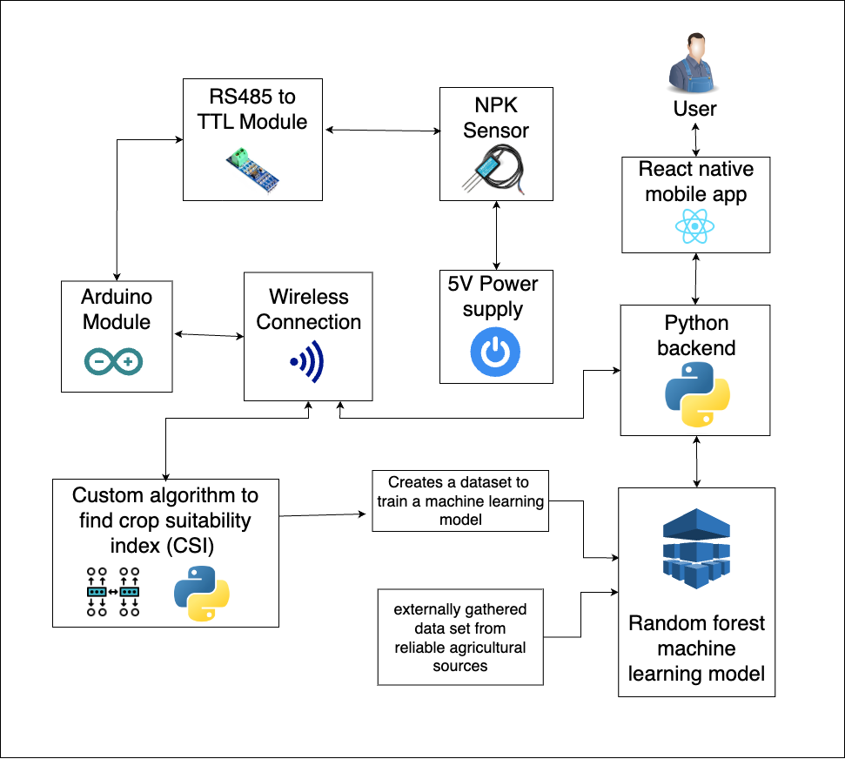
Individual System Diagram

4.3.3 Implementation

4.1 Data Collection and Preprocessing
In the initial phase of our implementation, we collaborated with gannoruwa agricultural research center to collect soil data. This data included essential parameters such as Nitrogen (N), Phosphorus (P), and Potassium (K) values, which are crucial for assessing soil health. Additionally, historical crop data, encompassing information about crop types and their performance in varying soil conditions, was obtained. The soil data was obtained through IoT devices, ensuring real-time and accurate measurements.

4.2 Data Exploration and Visualization
With the acquired dataset in hand, we conducted a comprehensive data exploration and visualization exercise. This involved generating summary statistics, visualizing the distribution of soil NPK values, and identifying potential outliers or anomalies. Through data visualization, we gained valuable insights into the relationships between NPK values and crop performance.

4.3 Data Integration

To enable precise crop recommendations based on soil conditions, we integrated the collected soil NPK values with historical crop data. Each set of NPK values was matched with its corresponding crop type, creating a comprehensive dataset that served as the foundation for our machine learning models.

4.4 Model Training

4.4.1 Random Forest Model

The Random Forest model was selected and trained to predict the most suitable crop for a given set of soil NPK values. The dataset was divided into training and testing sets, and the Random Forest model was fitted to the training data. Model performance was assessed using a range of metrics, including accuracy, precision, recall, and F1-score, ensuring robust predictive capabilities.

4.4.2 Decision Tree Model

In addition to the Random Forest model, we explored the Decision Tree model as an alternative approach for crop prediction. Similar to the Random Forest model, data splitting, model training, and performance evaluation were conducted to assess its suitability.

4.4.3 Support Vector Classifier

The Support Vector Classifier was another machine learning model considered for crop prediction. Training and evaluation processes were carried out to determine its effectiveness in providing accurate crop recommendations based on soil NPK values.

4.5 Integration with IoT Device

To enhance the real-time functionality of our precision agriculture system, we seamlessly integrated it with an IoT device capable of measuring soil NPK values. This integration ensures that the system receives continuous updates about soil conditions, allowing for timely and accurate crop recommendations that adapt to changing soil parameters.

4.6 Knowledge Base Development

In tandem with system development, we engaged in knowledge gathering from agricultural experts. We conducted on-site visit to agricultural research center in gannoruwa and actively participated in discussions with experts who possess profound insights into traditional farming practices. This knowledge was invaluable in ensuring that our system not only leverages modern technology but also respects and integrates traditional wisdom.

This comprehensive approach to implementation ensures that our precision agriculture system is rooted in both modern technology and traditional agricultural expertise. It allows us to deliver timely and context-aware crop recommendations based on real-time soil NPK values, benefiting local farmers and optimizing crop yields.

Deployment and Maintenance

Tools and Technologies

Commercialization

TESTING & IMPLEMENTATION
The Testing and Implementation phase, a pivotal component of the Software Development Life Cycle (SDLC), is instrumental in ensuring the precision agriculture system's functionality and reliability. Much like the assessment of an expenditure management application, we rigorously evaluated our machine learning models by providing simulated soil NPK values as inputs to gauge their ability to accurately classify soil conditions and offer precise crop recommendations. Beyond standard unit testing, we conducted a comprehensive evaluation in both local and cloud environments, identifying and addressing potential deployment issues. Real-world simulations using AWS EC2 instances validated the system's performance under various loads, ensuring its capacity to handle a substantial number of requests. This extensive testing reaffirmed the system's dependability, scalability, and high-quality results, aligning with user requirements and project goals.

Test Plan and Strategy

Test Case Design

Table 3: XXXXXXXXXXXXXXXX
Test Case ID | 01
Test Case | XXXXXXXXXXXXXXXX
Test Scenario | XXXXXXXXXXXXXXXXXXXXX
Input | XXXXXXXXXXXXXXXXXXXX
Expected Output | XXXXXXXXXXXXXXXXXX
Actual Result | XXXXXXXXXXXXXXX
Status(Pass/Fail) | XXXXXXXXXXXXXXXXXXX

RESULTS & DISCUSSION

Results

Research Findings

Discussion

CONCLUSION
XX.

REFERENCES

APPENDIX A: SURVEY

Appendix A. 1: Survey Description

Appendix A. 2: Survey Questions from 2 to 4

Appendix A. 3: Survey Questions from 5 to 8

Appendix A. 4: Survey Question 9

Appendix A. 5: Survey Question 10

Appendix A. 6: Survey Questions 11 and 12

Appendix A. 7: Survey Question 13

Appendix A. 8: Survey Question 14

Appendix A. 9: Survey Questions 15 and 16

Appendix A. 10: Survey Questions 17 and 18

Appendix A. 11: Survey Questions 19 to 21

Appendix A. 12: End of Survey Questions

APPENDIX B: WORK BREAKDOWN CHART
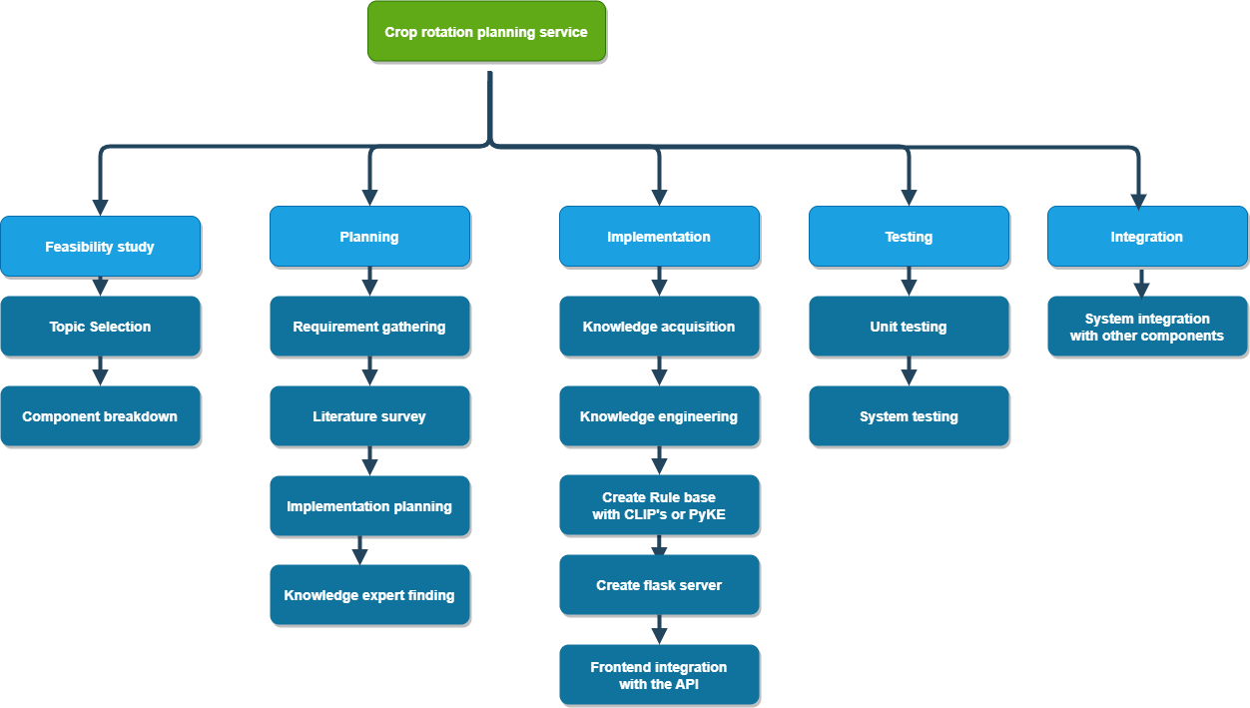
Appendix B. 1: Work Breakdown Chart

APPENDIX C: GANTT CHART
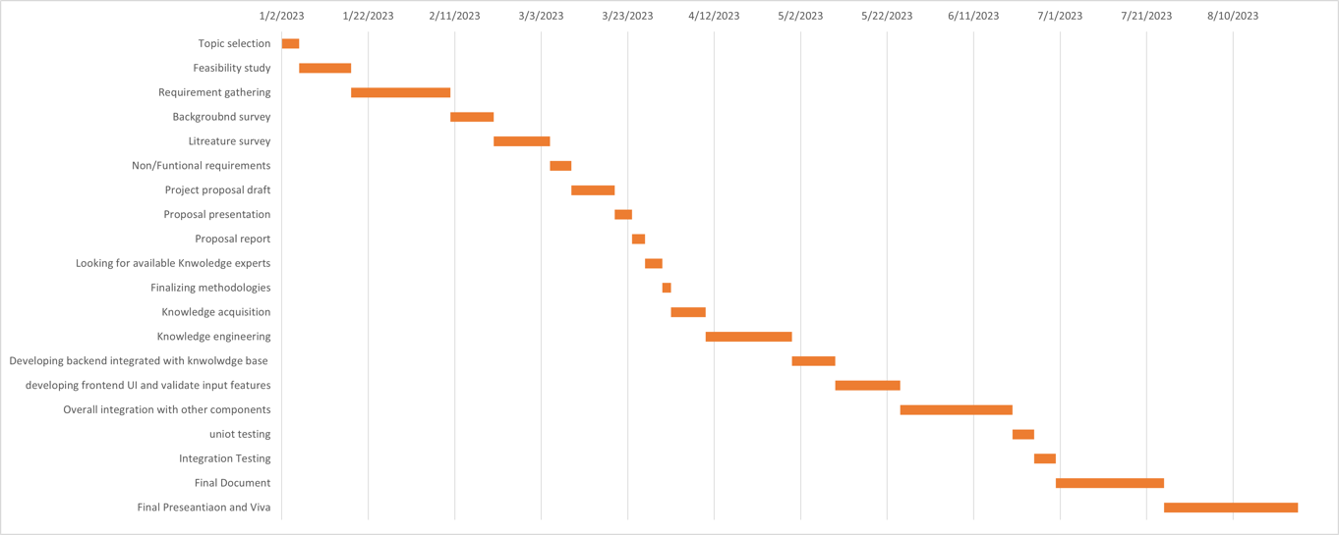
Appendix C. 1: Gantt Chart

APPENDIX D: PLAGIARISM REPORT

Appendix D. 1: Turnitin Report

