SMART SYSTEM FOR OPTIMIZED ORGANIC CROP
ROTATION USING PRECISION AGRICULTURE DATA

Waththaladeniya N.M

(IT20151874)

Bachelor of Science Special (Hons) in Information Technology Specialization in Software Engineering

Department of Computer Science and Software Engineering

Sri Lanka Institute of Information Technology
Sri Lanka

September 2023

SMART SYSTEM FOR OPTIMIZED ORGANIC CROP
ROTATION USING PRECISION AGRICULTURE DATA

Waththaladeniya N.M

(IT20151874)

Dissertation submitted in partial fulfillment of the requirements for the Bachelor of Science (Hons), Information Technology, Specialization in Software Engineering

Department of Computer Science and Software Engineering

Sri Lanka Institute of Information Technology
Sri Lanka

September 2023

DECLARATION
I declare that this is my own work when considering my individual components of the research,and this dissertation does not incorporate without acknowledgment any material previously submitted for a degree or diploma in any other university or institute of higher learning and to the best of our knowledge and belief it does not contain any material previously published or written by another person except where the acknowledgment is made in the text.

Name | Student ID | Signature
Waththaladeniya N.M | IT20151874 | 

The above candidates are carrying out research for the undergraduate Dissertation under my supervision.

Signature of the supervisor Date

ABSTRACT
Sri Lanka's agriculture industry plays a significant role in the nation's economy by supplying food, fiber, and other necessary resources. The sector must embrace sustainable techniques like organic farming, as well as deal with issues like soil deterioration and insect and disease management. Due to its capacity to enhance soil fertility and health, encourage biodiversity, and provide safe and wholesome food, organic farming is growing in popularity in Sri Lanka. Nonetheless, the sector needs to create organic agricultural practices that are climate change resistant and can boost crop productivity. Creating climate-resilient farming practices that can survive the effects of climate change is one of Sri Lanka's biggest problems in organic farming. Crop yields, the quality of the soil, and biodiversity are all threatened by changing weather patterns, including temperature swings, fluctuating rainfall, and extreme weather events. Farmers in Sri Lanka must gather and share information on regional weather patterns and how they affect crops in order to meet this issue. Then they can plant crops based on the weather condition and they can traditional methods to reduced the effected on weather changes. Real-time weather information may also help Sri Lankan farmers choose the best crops to cultivate and follow crop rotation plans that improve soil health, lower insect and disease pressure, and boost agricultural yields. The adoption of organic farming practices that are climate resilient is essential for the development of sustainable and productive agricultural systems in Sri Lanka. The system provide crops and methods to reduce the weather affect on crops using decision tree algorithm. This will enhance sustainable agriculture by assisting Sri Lankan farmers in making educated decisions on how to lessen the impact of varying weather patterns on crops, boost yield, and do so.

Keywords – Organic Farming, climate, weather, crop

ACKNOWLEDGEMENT
I would like to express my sincere gratitude and appreciation to my supervisor, Mr Udara Samaratunga, and co-supervisor, Dr. Nuwan Kodagoda, for their invaluable guidance, encouragement, support, and dedication throughout my one-year research journey. Their advice and assistance have been continuous support in guiding the direction of our research project(RP) and making it a success without any undue pressure. I am truly grateful for their constant availability and willingness to help whenever needed and it was a great privilege to work with them during this research. I also extend my heartfelt thanks to Dr. Jayantha Amararachchi, the Lecture in Charge of the Research Module, for his insightful lectures and constant guidance throughout one year that has helped me to understand the research module more thoroughly. My parents deserve a special mention for their unending support and care throughout my academic journey. Their limitless support has been a source of inspiration and motivation for me to reach my academic goals. I would also like to thank my three group members for their continuous commitment, team spirit, and hard work throughout this research journey that has made this research project a success. It has been an honor to work with such a dedicated team, and I am grateful for their support and encouragement. Finally, I would like to express my sincere gratitude to the research panel, TAF Panel, and CDAP staff for their valuable advice, instructions, and time and for accepting our research topic by giving us the chance to do this research.

TABLE OF CONTENTS

DECLARATION II
ABSTRACT II
ACKNOWLEDGEMENT III
TABLE OF CONTENTS IV
LIST OF FIGURES VI
LIST OF TABLES VII
LIST OF APPENDICES VIII
LIST OF ACRONYMS AND ABBREVIATIONS IX
1 INTRODUCTION 1
1.1 Background & Literature Survey 2
1.2 Research Gap 9
2 RESEARCH PROBLEM 12
3 OBJECTIVES 13
2.1 Main Objective 13
2.2 Specific Objectives 14
4 METHODOLOGY 15
4.1 Problem Statement 15
4.2 Requirement Gathering and Analysis 15
4.3 System Design and Implementation 17
4.3.1 Overall System Diagram 17
4.3.2 Individual System Diagram 19
4.4 Data Collection 21
4.5 Implementation 22
4.5.1 Creating the Expense Classification Model 22
4.6 Application Implementation 29
4.7 Deployment and Maintenance 29
4.8 Tools and Technologies 29
4.9 Commercialization 30
5 TESTING & IMPLEMENTATION 31
5.1 Test Plan and Strategy 31
5.2 Test Case Design 33
6 RESULTS & DISCUSSION 38
6.1 Results 38
6.2 Research Findings 45
6.3 Discussion 48
7 CONCLUSION 49
REFERENCES 50
APPENDIX A: SURVEY 52
APPENDIX B: WORK BREAKDOWN CHART 59
APPENDIX C: GANTT CHART 60
APPENDIX D: PLAGIARISM REPORT 61

LIST OF FIGURES

Figure X.X: XXXXXXXXXXXXXXXXXXXXXXXXX X7

LIST OF TABLES

Table 8: XXXXXXXXXXXXXXXXXXXX. X8

LIST OF APPENDICES
Appendix A. 1: Survey Description 52
Appendix A. 2: Survey Questions from 2 to 4 53
Appendix A. 3: Survey Questions from 5 to 8 54
Appendix A. 4: Survey Question 9 55
Appendix A. 5: Survey Question 10 55
Appendix A. 6: Survey Questions 11 and 12 55
Appendix A. 7: Survey Question 13 56
Appendix A. 8: Survey Question 14 56
Appendix A. 9: Survey Questions 15 and 16 57
Appendix A. 10: Survey Questions 17 and 18 57
Appendix A. 11: Survey Questions 19 to 21 58
Appendix A. 12: End of Survey Questions 58
Appendix B. 1: Work Breakdown Chart 59
Appendix C. 1: Gantt Chart 60
Appendix D. 1: Turnitin Report 61

LIST OF ACRONYMS AND ABBREVIATIONS
Table 1: List of Acronyms and Abbreviations
Abbreviations  RP  SLIIT  CRM  UI  IOT  DB  CSI  UX | Description  Research Project  Sri Lanka Institute Of Information Technology  Crop Rotation Management  User Interface  Internet Of Things  Database  Crop Sutaibility index  User Experience

1 INTRODUCTION
Most economies depend on agriculture to provide them with the foodstuff, cellulose, and other resources they need to preservehuman existence. Nonetheless, the industry has several challenges, such as deteriorating soil fertility and health, managing pests and diseases, and the requirement to use productive and sustainable agricultural practices, such as organic farming. Due to its capacity to improve soil fertility and health, encourage biodiversity, and create wholesome and secure food, organic farming is becoming more popular. Nonetheless, the industry still has a long way to go before adopting organic agricultural methods that can withstand climate change while also enhancing crop yield. The development of climate-resilient methods that can survive the effects of climate change is one of the serious issues facing organic farming. Crop yields, soil health, and diversity are seriously threatened by changing weather patterns, including changes in temperature, variable rainfall, and extreme weather. To help farmers reduce the effects of shifting weather conditions on their organic crops, discovering local variations in weather variables such as temperature, precipitation, humidity, wind, and extreme weather conditions might be useful. Data collection and dissemination on local weather patterns and their effects on crops are critical steps in establishing climate-resilient organic agricultural methods1. This data can allow farmers to plan their farming activities, including planting, harvesting, and crop rotation, depending on the projected weather conditions. For instance, if farmers are aware of anticipated rainfall patterns, they may plan irrigation and drainage systems to guarantee the most efficient use of water, minimize soil erosion, and enhance crop development. Also, based on the crops' resilience to specific weather conditions, the data can assist farmers in selecting the right crops to produce. Farmers might select crops that can withstand droughts, such millet or sorghum, if their area is frequently hit by droughts. Similarly, farmers may select crops resistant to fungal infections in areas with extreme amounts of humidity, such as resistant tomato cultivars. Moreover, the data can support crop rotation methods that enhance soil fertility and health, reduce pest and disease occurrences, and increase crop yields2. Planting several crops in succession throughout time is a sustainable and profitable
agricultural strategy known as crop rotation. This method promotes biodiversity, enhances soil health and fertility, and breaks the life cycle of pests and illnesses. Developing sustainable and effective agricultural systems depends on organic farming techniques that are climate resilient. Real-time weather data may be used in organic farming techniques to help farmers make decisions on how to reduce the effects of varying weather patterns on crops3, increase productivity, and support sustainable agriculture. To achieve this aim, it is necessary to encourage the use of organic agricultural methods that are climate resilient as well as the collection and dissemination of local meteorological data.

Background & Literature Survey
Climate change is one of the most significant challenges faced by the agricultural sector. Existing farming methods, such as the overdependence on chemical pesticides and fertilizers, are increasingly seen to be unsustainable and harmful to the long-term health of the ecosystem. To lessen the effects of climate change on agriculture, these people are turning to organic farming methods, which prioritize the use of natural inputs and put a high priority on soil health and diversity. Implementing climate-resilient organic farming techniques, however, still comes with many difficulties, including the requirement to watch local weather patterns and provide farmers real-time advice on adapting to changing conditions. Weather is the conclusion of the many climatic variables that are now existing, including temperature, wind direction and speed, precipitation amount and kind, sunshine hours, humidity, and extreme weather. So, climate change affects the production of the agricultural sector in separate ways.

Maintaining soil health and fertility in the face of changing weather conditions is one of the biggest problems faced by organic farmers. Extreme weather conditions like droughts and floods, however, can have a significant impact on the fertility and health of the soil, making it challenging for farmers to maintain their crops. Another issue is expected amount of rain may not occur during the expected time because of rainfall pattern changes. So, without having expected water to the crops, farmers cannot get good production and have more than expected rainfall effect on soil health and fertility. Researchers have invented a variety of organic farming techniques that are climate-resilient to reduce the impact of changing weather patterns while simultaneously enhancing soil health and fertility. Researchers have created several organic farming techniques that are climate resilient to solve this problem by increasing soil health and fertility while reducing the effect of changing weather patterns. For instance, some farmers use cover cropping techniques, where a range of crops are planted successively to enhance soil health and lower erosion. Some farmers have adapted the no-till farming method4, which requires leaving cover crops on the soil surface to prevent harm and boost soil organic matter.

In Sri Lanka, organic farming is becoming increasingly popular, and the importance of developing climate-resilient farming techniques is becoming more apparent. There are many various climatic zones in the country, which can make it hard for farmers to adjust to changes in the weather. With the country's numerous natural assets and agricultural history, Sri Lanka also has a lot of potential for organic farming. The use of conventional rice-farming techniques in Sri Lanka, such as the use of organic fertilizers and the management of diverse crop rotations, is one example of a climate-resilient organic farming practice. These techniques have been found to increase soil fertility and health while also making crops more resilient to changing weather conditions. To assist climate-resilient organic farming, Sri Lanka is also developing several modern technologies and methods, including the use of precise irrigation systems and the creation of weather monitoring networks. Along with these methods, using precision agriculture technology like real-time weather monitoring and remote sensing can be a useful tool for organic farming that is climate resilient. Some researchers found that the weather monitoring system gets all the details of weather changer for number of days. Farmers can use that technology to get detailed data on soil moisture levels, plant development, and nutrient availability to help them determine when to water, fertilize, or harvest their crops. Similarly, real-time weather monitoring systems may give farmers current details on regional weather, enabling them to modify their farming techniques. There are some researchers who have found a real time weather monitoring system which can be used to get current weather changes like precipitation, wind, rain fall and humidity. That will help farmers to identify daily weather changes according to the system.

The creation of organic farming techniques that are climate resilient is essential for the long-term sustainability of agriculture, especially considering climate change. Farmers may improve the fertility and health of their soil while effectively adjusting to changing weather conditions by using techniques like cover crops, no-till farming, and precision agriculture. The application of modern technology, such as remote sensing and real-time weather monitoring, may also be a powerful tool for organic farming that is climate resilient. Given the wide range of climatic zones and agricultural history of Sri Lanka, there is a lot of opportunity for the development of climate-resilient organic farming techniques there. Farmers in Sri Lanka and other countries may try to reduce the effects of climate change on agriculture while improving overall long-term environmental health by supporting the development of these techniques.

Research Gap
A recent trend in Sri Lanka is organic farming, which can encourage environmentally friendly and sustainable agricultural methods. So far, organic farming in Sri Lanka faces similar difficulties as in other countries in implementing climate-resilient methods that might reduce the effects of climate change on crops and increase their yield. The lack of knowledge on the interactions between organic farming techniques and climate change is one study gap in Sri Lankan organic farming that is climate resilient. Although it is well established that organic farming promotes soil health and fertility, further research is required to determine the actual effects of climate change on Sri Lanka's soil health and fertility, as well as the possibility for organic farming to lessen these effects5. For instance, it is not apparent how shifting weather patterns affect the availability of soil nutrients or how organic farming techniques in Sri Lanka might enhance soil nutrient cycling in the face of climate change. There are some researchers who find weather monitoring systems that provide real time weather conditions to the farmers. Then the farmers need to identify what method they need to use to reduce the impact of weather changes.

More study is required to better understand how resilient Sri Lankan organic crops are to changing weather patterns. In Sri Lanka, organic crops are frequently cultivated without the use of artificial fertilizers and pesticides, rendering them more susceptible to the effects of climate change. It is necessary to look at how resilient organic crops are in Sri Lanka to various climatic conditions, such as drought, floods, and extremely high temperatures. Finding the best organic farming methods in Sri Lanka for certain crops under various climatic conditions is also necessary. There are some weather monitoring systems, but they do not provide which method farmers need to use when the weather conditions change6. Pest and disease management might become more difficult due to shifting weather patterns, which can affect pest and disease populations and their interactions with crops. The effects of climate change on pest and disease populations in Sri Lanka and how they interact with crops must be studied, as must the possibility for organic farming methods to lessen these effects.

Also, there is a need to create data and resources to aid Sri Lankan farmers in using organic agricultural methods that are climate resilient. Although Sri Lanka already has tools and rules for organic farming, it is necessary to adapt these materials to local weather patterns and combine real-time weather information to provide farmers more precise and timelier advice. The creation of tools and resources that can assist Sri Lankan farmers in modifying their farming methods to change weather patterns and managing the issues related to climate change is also necessary. Further study is required on Sri Lanka's climate-resilient organic farming techniques and economic feasibility. While organic farming in Sri Lanka can support ecologically benign and sustainable agricultural practices, it can also be more labor-intensive and expensive up front than conventional farming. To determine possible obstacles to their adoption, it is necessary to look at the financial costs and advantages of various climate-resilient organic agricultural techniques in Sri Lanka.

RESEARCH PROBLEM
There is a lack of empirical research on the efficiency of using realtime weather data to improve climate resilience and production in organic farming systems, despite the rising interest in climateresilient organic farming techniques in Sri Lanka8. By examining the effects of real-time meteorological data on Sri Lanka's climateresilient organic agricultural methods and production, this study seeks to close this research gaps. The research issue is crucial in Sri Lanka because organic farming is a viable strategy to reduce the negative effects of climate change on agricultural systems. Climate change poses a serious challenge to the country's food security. To enhance the livelihoods of Sri Lanka's smallholder farmers and produce food and fiber sustainably, organic farming techniques must be climate resilient9. By giving farmers timely and pertinent information on weather patterns that might help them make informed decisions about farming operations and increase production, real-time weather data has the potential to improve the resilience of organic agricultural techniques.

Despite the potential advantages of using current weather information in organic farming in Sri Lanka, there is no empirical research on how effective it is at realizing and climate resilience. The majority of research have focused on the effects of climate change on Sri Lanka's organic agricultural systems, paying little attention to how real-time weather data might increase climate resilience. By examining the effects of real-time meteorological data on Sri Lanka's climate-resilient organic agricultural methods and production, this study aims to close this gap.

The following research questions will be used to answer the research problem:
- What effects do real-time weather data have on Sri Lanka's
climate-resilient organic farming practices?
- How do crop rotation and crop selection in Sri Lanka's organic
farming systems depend on current weather information?
- What connection exists between crop yield and quality in Sri
Lanka's organic farming methods and current weather
parameters?

The study will employ a mixed-methods approach, integrating quantitative and qualitative data gathering and analytic techniques, to address these research issues. The study will take place in a few organic farming areas in Sri Lanka, where weather unpredictability and climate change have a big impact on agricultural systems. A
survey of Sri Lankan organic farmers will be conducted for the project in order to gather information on their farming practices, such as crop choice, rotation, and irrigation techniques, as well as how they make use of current meteorological information. The study will also gather information on crop yields and quality, as well as farmers' opinions of how effectively Sri Lankan climate resilience and productivity are being improved by real-time weather data.

The research will also convene focus groups with farmers and important stakeholders in Sri Lanka, including agricultural extension agents and meteorological authorities, to collect qualitative information on the difficulties and advantages of utilizing real-time weather data in organic farming techniques. The focus group talks will also look at potential obstacles to real-time weather data adoption and how to encourage organic farmers in Sri Lanka to use it3. The quantitative data in the research will be
studied using descriptive statistics and regression analysis, while the qualitative data will be analyzed using theme analysis. The results of the study will present empirical evidence on the effects of real-time weather data on Sri Lankan organic farming productivity and climate-resilient farming practices, as well as on the difficulties and opportunities of using real-time weather data in Sri Lankan
organic farming systems.

OBJECTIVES

Main Objective
Our main goal is to use precision agriculture data to build and deploy a resilient and adaptable smart system for optimized organic crop rotation. This technology provides a comprehensive solution to the persistent problems caused by erratic and variable weather that have a big influence on the agricultural industry. The main objective is to provide farmers with data-driven insights and recommendations that will help them minimize the negative consequences of severe weather fluctuations and increase crop yields.

The sector of agriculture is naturally susceptible to the unpredictability of weather patterns. Variations in the weather can have an impact on insect and disease outbreaks, crop growth, soil quality, and the general sustainability of farming operations. Our research aims to offer a comprehensive solution that will empower farmers and lessen the adverse effects of weather-related uncertainties in this particular setting.

The objective of this study is to close the knowledge gap regarding weather patterns' dynamic nature and conventional farming techniques. With the use of precision agriculture data and an intelligent system, we hope to provide farmers with the knowledge and resources necessary to make decisions that are specific to their situation. This comprises crop rotation plan optimization based on historical insights, predictive modeling, pest and disease details, soil health, and real-time meteorological data. Assisting farmers to proactively adjust to changing weather conditions is the primary objective. Farmers will be able to modify their operations in response to certain weather events thanks to the system's real-time weather monitoring and advice. By doing this, we hope to reduce agricultural losses caused on by weather-related problems like droughts, sudden downpours, and extremely high temperatures.

Specific Objectives
Data Collection and Analysis
- Gather and meticulously catalog region-specific data, focusing on Sri Lanka's unique climate and agricultural landscape. This includes detailed weather variables, historical crop yields, and agricultural information relevant to the region.
- Employ advanced data analysis techniques to unravel the complex relationships between weather conditions and crop growth and yield in the Sri Lankan context. This analysis will guide the development of tailored recommendations for local farmers.

Real-time weather monitoring system

Monitor real time weather variables like humidity, rainfall, temperature, and wind using IOT (Internet of Things) device to collect the current weather conditions.

Data processing

Analyze the data collected by the sensors and the other data sets to recommend a
crop to farmers based on their area's weather conditions.

METHODOLOGY

Problem Statement

Requirement Gathering and Analysis

System Design and Implementation

Overall System Diagram

Individual System Diagram

Data Collection

Implementation

Creating the Expense Classification Model

Deployment and Maintenance

Tools and Technologies

Commercialization

TESTING & IMPLEMENTATION

Test Plan and Strategy

Test Case Design

Table 3: XXXXXXXXXXXXXXXX
Test Case ID | 01
Test Case | XXXXXXXXXXXXXXXX
Test Scenario | XXXXXXXXXXXXXXXXXXXXX
Input | XXXXXXXXXXXXXXXXXXXX
Expected Output | XXXXXXXXXXXXXXXXXX
Actual Result | XXXXXXXXXXXXXXX
Status(Pass/Fail) | XXXXXXXXXXXXXXXXXXX

RESULTS & DISCUSSION

Results

Research Findings

Discussion

CONCLUSION
XX.

REFERENCES

APPENDIX A: SURVEY

Appendix A. 1: Survey Description

Appendix A. 2: Survey Questions from 2 to 4

Appendix A. 3: Survey Questions from 5 to 8

Appendix A. 4: Survey Question 9

Appendix A. 5: Survey Question 10

Appendix A. 6: Survey Questions 11 and 12

Appendix A. 7: Survey Question 13

Appendix A. 8: Survey Question 14

Appendix A. 9: Survey Questions 15 and 16

Appendix A. 10: Survey Questions 17 and 18

Appendix A. 11: Survey Questions 19 to 21

Appendix A. 12: End of Survey Questions

APPENDIX B: WORK BREAKDOWN CHART
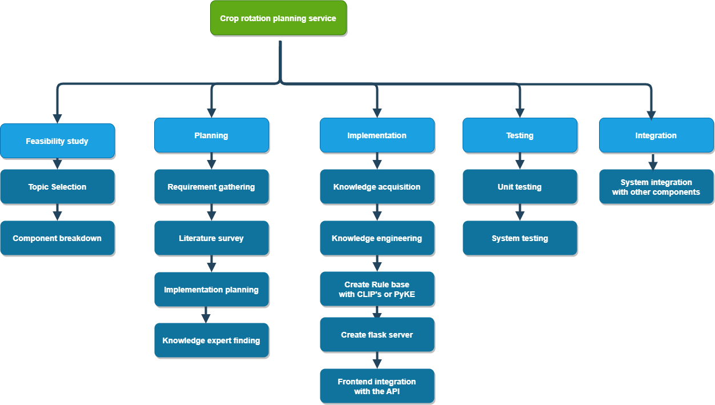
Appendix B. 1: Work Breakdown Chart

APPENDIX C: GANTT CHART
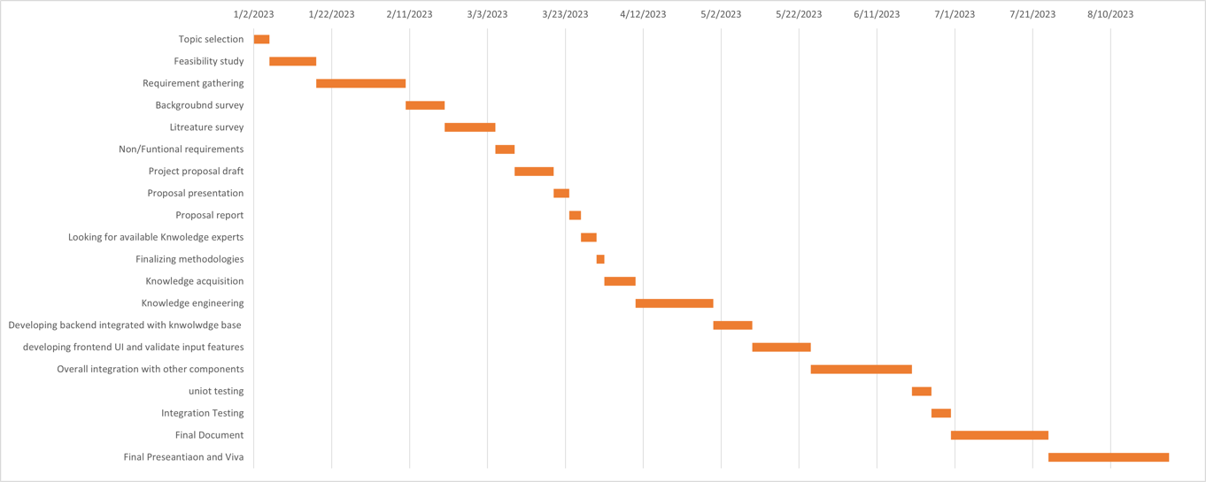
Appendix C. 1: Gantt Chart

APPENDIX D: PLAGIARISM REPORT

Appendix D. 1: Turnitin Report

